**Interactive Question Generator for Children**

**Introduction**

In our modern times, people need teachers, instructors and professors to teach them in reading comprehension. They need teachers to check if these people can comprehend articles or stories. What if there is no teacher available to teach them? How will these people check their comprehension abilities?

As of today, technology has been playing a great role in human lives and new developments in technology continue to arise. One of these is Natural Language Processing (NLP) or simply the process of making computers understand text or information in the form of human readable language.

Question generation is the task of automatically generating question from various inputs such as raw text, database or semantic representation (Paul P.). The generation of question needs information from a text or sentences.

The goal of the researchers is to create an automated system that can take a children story as an input and produce an output questions for assessing a reader’s knowledge about the story. The system will also give the correct answer on the generated questions.

**Problem Statement**

How will the system be effective and efficient in generating questions and answers?

* **What is the optimized parser to use in analyzing?**

1. **Lemmatization**

* **What is the solution in generating a question that is grammatically correct, easy to comprehend and answerable by children?**

1. **Handling of quoted words**
2. **Question difficulty control**
3. **What kinds of questions to produce (factoids, list, analogy, essay, and etc.)?**

* **Generating a correct and accurate answer-key**
* **What are the suitable algorithms to use for the system?**

1. **Algorithm(s) for Question Generation**
2. **Algorithm for creating an answer key**

**Review of Related Literature**

According to Xuchen Yao (2010), Question Generation (QG) is the task of generating reasonable questions from a text. It is a joint effort between Natural Language Understanding (NLU) and Natural Language Generation (NLG). Simply speaking, if natural language understanding maps text to symbols, and natural language generation maps symbols to text, then question generation maps text to text through an inner mapping of symbols for declarative sentences to symbols for interrogative sentences.

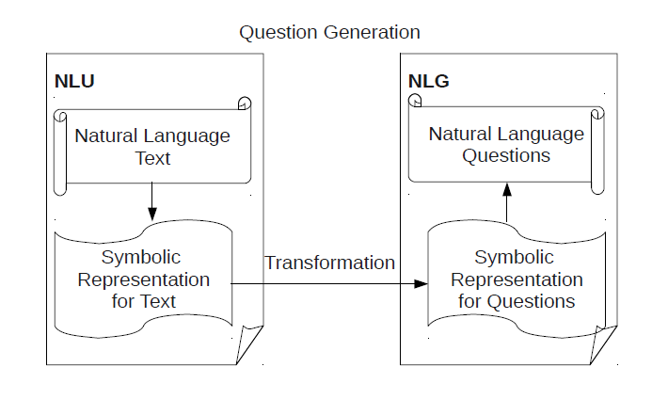

Same as the goal of the study of (Heilman M.) the proponents aim to create a system that accepts text as input and output a set of questions which can be used as an assessment tool for the reader’s comprehension.

The image below is an excerpt from the study of (Heilman M.) which demonstrates the process of his system in generating a question from a text.

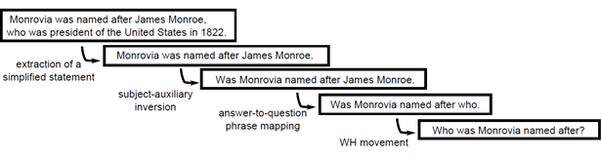

The said study uses Named Entity Recognition and Lexical-Syntactic processes. (Heilman M.) recommended in his study that narratives and subjective essays would also be interesting and educationally relevant which can be subject to question generation. Going back to the research of (Xuchen Yao), he mentioned different types of questions to be generated by a given system, some of these are as follows: “factoid” or questions based on facts, “lists” or the questions that requires a set of answer. In terms of target complexity, the type of QG can be divided into *deep* QG and *shallow* QG (Rus and Graesser 2009). Deep QG generates deep questions that involves more logical thinking (such as why, why not, what-if, what-if-not and how questions) whereas shallow QG generates shallow questions that focus more on facts (such as who, what, when, where, which, how many/much and yes/no questions).

**Project Description**

A successful implementation of Information Extraction (IE) a subfield of Natural Language Processing (NLP) is vital for the study. IE is the discipline concerned with extracting structured information from unstructured text (Krishnamurthy et. al). Since a narrative story is an unstructured text and we need to extract structured information from it, the researchers have hypothesized that IE is the perfect method to implement. We plan to extract information from the given text and from that extracted information, process and generate sets of questions. The implementation of Named Entity Recognition and Part Of Speech tagging is possible in this study.

**Bibliography**